SIMATS ENGINEERING
ASSESSMENT TOOL 3

AYUSH MOHAPATRA 192411263
COURSE NAME: INTERNET PROGRAMMING
COURSE CODE: CSA43
COURSE OUTCOME COVERED
CO-1: Develop well-structured, standards-compliant web pages using HTML/XHTML and XML, and apply Internet protocols and HTTP communication mechanisms for web content delivery. (L2)
Assessment Tool: Code along exercise: Make your first HTML page together with CSS
Weightage: 10%
QUESTIONS: Total Marks: 10
Scenario: Web Development Standards Implementation
A start up is developing a modern web application. During development, the team encounters multiple issues related to HTML elements, HTTP methods, XML syntax, and web communication protocols.
The following observations are made:
● The team needs to embed a promotional video on the homepage. ● A registration form must securely send user data to the server.
● The navigation menu must follow semantic HTML standards.
● XML configuration files are being used but contain syntax errors.
● The application must communicate over the correct web protocol.
Data Snippets Provided
Snippet 1: Video Embedding Options
A. <media src="video.mp4"></media>
B. <video src="video.mp4" controls></video>
C. <movie src="video.mp4"></movie>
D. <vid src="video.mp4"></vid>
Snippet 2: Form Submission Methods
A. GET
B. POST
C. PUT
D. DELETE
Snippet 3: Navigation Elements
A. <div>
B. <nav>
C. <section>
D. <header>
Snippet 4: XML Syntax
A. <note><to>User</to><from>Admin</from>
B. <note><to>User</to><from>Admin</from></note>
C. <note><to>User</from></note>
D. <note to="User"></note
Snippet 5: Web Communication Protocols
A. FTP
B. HTTP
C. SMTP
D. SNMP
Questions:
1. Select the correct HTML tag for video embedding and justify your answer.
2. Identify the appropriate HTTP method for form submission and explain why. 3. Choose the proper semantic element for navigation and justify its usage.
4. Identify the correct XML syntax and explain the error in other options.
5. Choose the correct protocol for web communication and justify your choice.

Code of Conduct:
I AYUSH MOHAPATRA 192411263 (Name / Reg No) certify that this submission is my original work and that I have adhered to the guidelines specified for this assessment. I understand that any violation of academic integrity rules will result in disciplinary action.
Signature of the student: AYUSH MOHAPATRA

SIMATS ENGINEERING
ASSESSMENT TOOL 3 – COMPLETED ANSWERS
Course: Internet Programming | Course Code: CSA43
Assessment: Web Development Standards Implementation | Total Marks: 10

Scenario Overview
The startup needs to embed a promotional video, submit registration data, use semantic navigation markup, correct XML syntax, and select the appropriate protocol for web communication. The answers below select the best option from each provided snippet and explain the choice.

1. Correct HTML Tag for Video Embedding
Correct option: B — <video src="video.mp4" controls></video>
Justification: The HTML <video> element is the standard element for embedding video content in a webpage. The src attribute identifies the video file, and the controls attribute allows users to play, pause, and control playback using the browser’s built-in interface. The other options (<media>, <movie>, and <vid>) are not standard HTML elements for video embedding.
Example:
<video src="video.mp4" controls>
Your browser does not support the video element.
</video>

2. Appropriate HTTP Method for Form Submission
Correct option: B — POST
Justification: POST is appropriate for submitting registration data because the form fields are sent in the request body rather than being placed in the URL query string. This is preferable for personal registration details and avoids exposing the data directly in browser history and copied URLs. However, POST alone does not encrypt data; HTTPS must be used to protect it in transit.
Example:
<form action="/register" method="post">
<label for="username">Username:</label>
<input id="username" name="username" required>
<button type="submit">Register</button>
</form>
The server should validate submitted fields and handle personal data securely. Use HTTPS for the form page and submission endpoint.

3. Proper Semantic Element for Navigation
Correct option: B — <nav>
Justification: The <nav> element represents a section of a page containing major navigation links, such as links to Home, About, Services, and Contact. It communicates the purpose of the section to browsers, assistive technologies, and developers. A <div> is generic, <section> groups thematically related content, and <header> represents introductory content or a header area; none is as specific as <nav> for navigation.
Example:
<nav aria-label="Main navigation">
<a href="/">Home</a>
<a href="/about">About</a>
<a href="/contact">Contact</a>
</nav>

4. Correct XML Syntax
Correct option: B — <note><to>User</to><from>Admin</from></note>
Justification: XML requires elements to be properly nested and closed, and every opening tag must have a matching closing tag. Option B correctly closes <to>, <from>, and the root <note> element.
Errors in the other options:
- Option A: The root <note> element is not closed, so the document is incomplete.
- Option C: The <to> element is opened but incorrectly closed with </from>; tag names must match.
- Option D: The opening <note> tag is not closed with >, so the markup is malformed.
Correct XML example:
<?xml version="1.0" encoding="UTF-8"?>
<note>
<to>User</to>
<from>Admin</from>
</note>

5. Correct Protocol for Web Communication
Correct option: B — HTTP
Justification: HTTP (Hypertext Transfer Protocol) is the application-layer protocol used for communication between web clients, such as browsers, and web servers. It defines how requests and responses are exchanged to retrieve webpages and other web resources. HTTPS is HTTP secured with TLS and should be used for modern applications, especially when transmitting registration data.
Why the other options are not the best answer:
- FTP is primarily used to transfer files.
- SMTP is used to send email.
- SNMP is used to monitor and manage network devices.
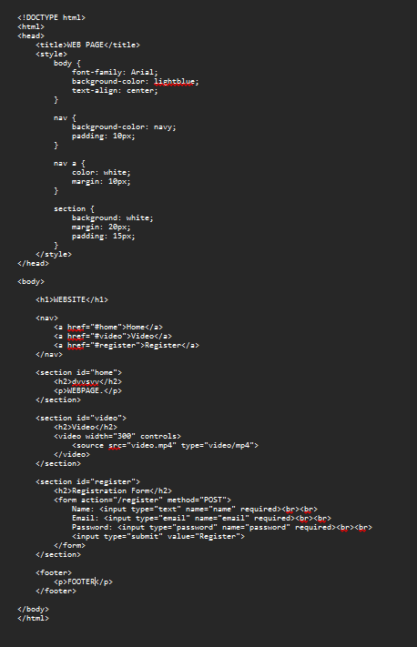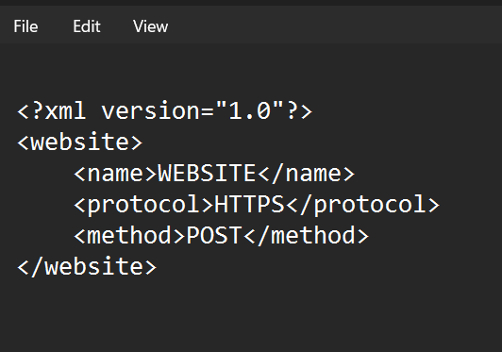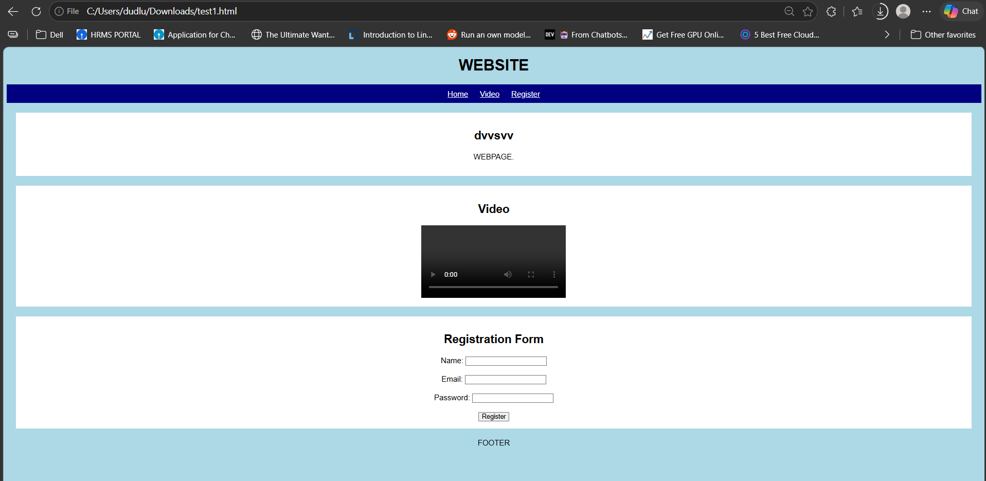

RUBRICS FOR CALCULATION:
Criteria | Weightage | Level 4 – Exemplary | Level 3 – Proficient | Level 2 – Developing | Level 1 – Beginning | Marks Awarded
Understanding of Case | 25 | Thorough understanding; clearly identifies all key issues | Good understanding with most issues identified | Basic understanding; some issues missed | Poor understanding; problem not identified correctly | 23 / 25
Application of Concepts | 25 | Effectively applies relevant concepts to analyze the case deeply | Applies appropriate concepts with minor gaps | Limited application of concepts | Fails to apply relevant concepts | 23 / 25
Analysis | 20 | In-depth analysis with strong reasoning and insights | Good analysis with logical reasoning | Basic analysis with limited depth | Weak or no analysis; lacks reasoning | 18 / 20
Solution Design | 20 | Innovative, feasible solutions with strong justification | Logical solutions with adequate justification | Basic solutions with weak justification | Incorrect or no solution provided | 18 / 20
Clarity | 10 | Clear, well structured, and easy to understand | Organized and understandable presentation | Limited clarity and structure | Poor clarity; difficult to understand | 9 / 10
Total Marks | 100 |  |  |  |  | 91 / 100

